**Enterprise Application Integration**

09

**Application Integration with BPEL**

**Assignment #3**

**Carlos Simões  
Miguel Graça Oliveira  
Pedro Saraiva**

# Introduction

In the scope of the project “Application Integration with BPEL”, from the assignment #3 of the Enterprise Application Integration course, a set of design and implementation decisions had to be made. The goal of this report is to describe these decisions.

In addition, the report provides the instructions for deploying and executing the application.

## Time Spent

|  |  |  |
| --- | --- | --- |
| Student | Mostly involved in | Time spent |
| Carlos Simões | * Web * Web-BPEL interface |  |
| Miguel Graça Oliveira | * BPEL Processes * JBoss Web Services * Project Report | Reading 3:30  Coding 34:20  Report 2:10 |
| Pedro Saraiva | * BPEL Processes * Web-BPEL interface | Reading 4:30  Coding 36:30  Report 0:20 |

# Installation Instructions

1. JBoss
   1. Extract JBossConfigurationFiles.zip to the deployment directory (as an example, C:\jboss-5.0.1.GA\server\default)
   2. Extract JBossWebServices.zip to the directory called deploy within the deployment directory (C:\jboss-5.0.1.GA\server\default\deploy)
   3. Execute the SQL files contained in JBossHypersonicSQLScripts.zip within the DatabaseManager.
2. Glassfish
   1. ?????

# Implementation and Design decisions

## Architecture

This project is an evolution of the previous project. The project goal was to add an orchestrator in order to deal with the business processes.

This was the previous architecture:





The first decision was to make each service as independent as possible. We identified two components as process initiators, which were the web component and the shipping department. The other components were service providers that also contained business logic.

Considering this, we dismembered the LPCO component into two components, Customer Services and Catalog Center. These components are web services that access the database of the camera store. In addition, we removed the business logic from these components, moving it over to the Process Orchestrator. An example would be the process where, when no result exists from a camera search on the database, the camera supplier has to be called in order to retrieve new cameras if they exist and add them to the database.

The new high-level architecture of the system is as follows:





We decided to keep the web services, even the new ones, running on JBoss as we were already using Hibernate on top of Hypersonic Database and the configuration was there. Considering the Web Component, which had to be changed in order to invoke the process orchestrator instead of the LPCO EJB, we decided to migrate over to Glassfish, for ease of development sake.

We decided that the Web Component would hold all the session information, contrary to the previous implementation where the session information was in the Session Bean. Due to this, we had to move the shopping cart and its methods, which were on the session bean before, to the web component. The motivation behind this decision was, again, simplicity.

## Service Providers

### Camera Supplier

This Web Service remains unaltered from the previous project. It represents an external entity that supplies cameras.

This web service is responsible to obtain all the cameras where the model name matches with the keyword. The web service is based on the use of a camera catalog xml file. To discover which cameras corresponds to the search criteria we decided to use XPATH. The origin of this web service call is from the LPCO that when does not have cameras that matches the search criteria, tries to obtain information from the Camera Supplier.

The cameras database xml file should have the name “camera_catalog.xml” and exist in the JBOSS server data folder.

### Customer Services

Customer Services is a new web service originated from the previous LPCO component. This web service provides operations that allow for authentication and registration of users. It also provides the operations required to check if the client has money (simulated by a random event), order management and purchase management. This web service interacts directly with the LPCO Database.

### Catalog Center

Catalog Center is a new web service originated from the previous LPCO component. This web service provides operations regarding only the camera catalog. This means that it allows adding new cameras, searching for cameras and getting information from a specific camera. This web service interacts directly with the LPCO Database, with the Catalog tables.

## Process Initiators

### Web Component

The Web Component provides a very simple interface that allows a user to interact with the system seamlessly. It invokes the web services of the process orchestrator when required by the user requests and displays the results to the user.

The Web Component is, unlike the previous project’s web component, deployed in Glassfish along with the Process Orchestrator.

### Shipping Department

The Shipping Department is notified by the Process Orchestrator when a purchase was completed. The Shipping Department then waits a random number of days, simulated by one day being equal to one second, and finally invoking, again, the process orchestrator saying that the order was shipped.

## Appendix A – BPEL Processes

### Process for user login

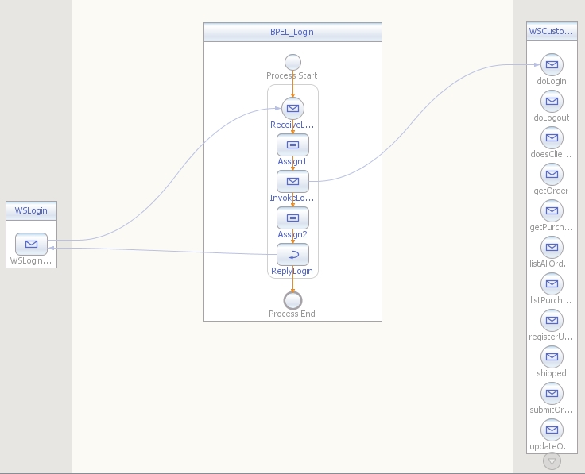

### Process to register a new user

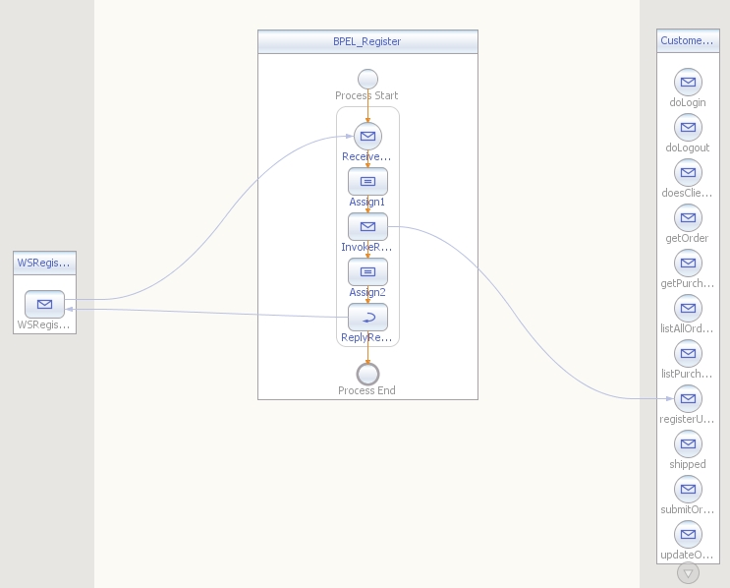

### Process to obtain information of a specific camera

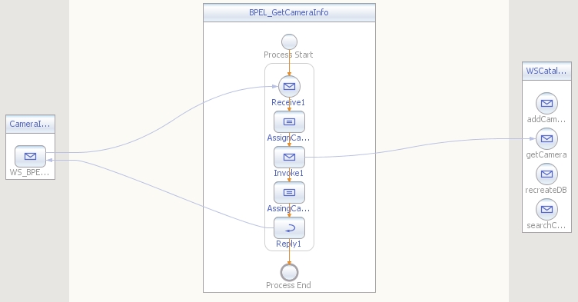

### Process to perform cameras search

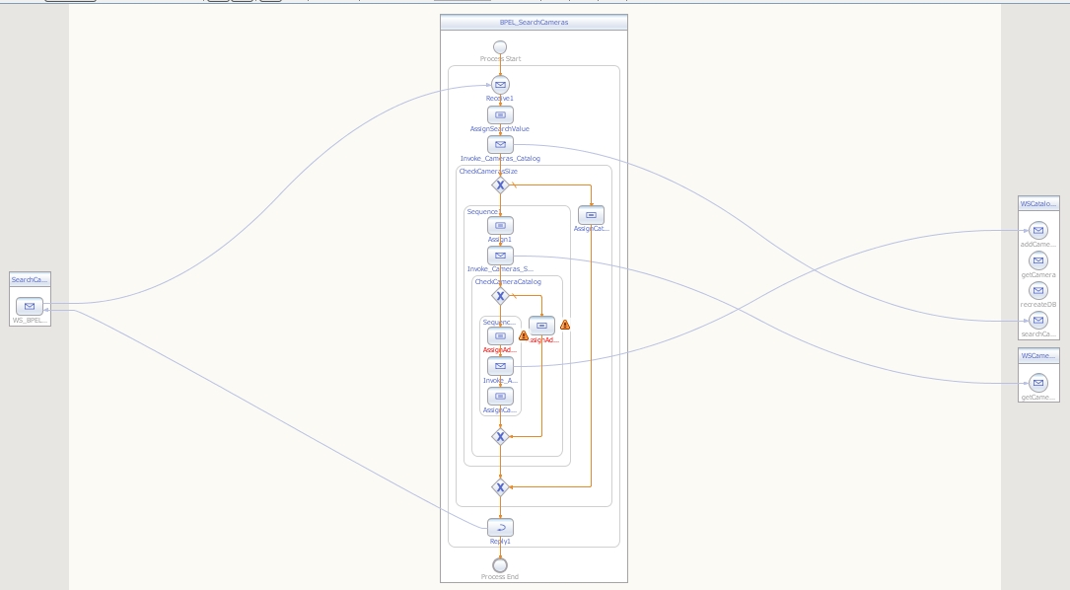

### process to obtain information about a specific purchase

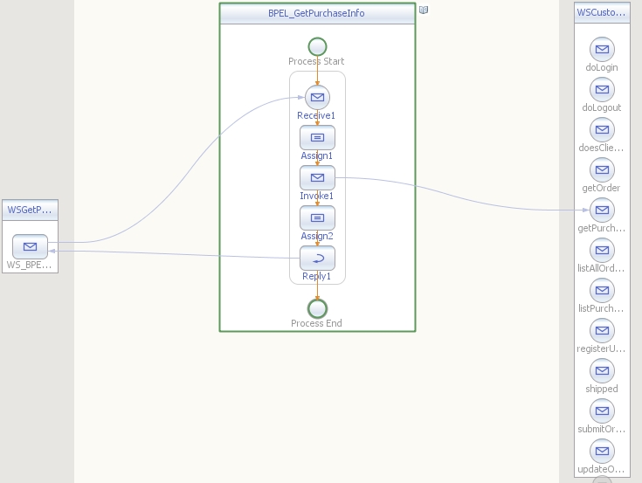

### process to obtain the purchases of a given user

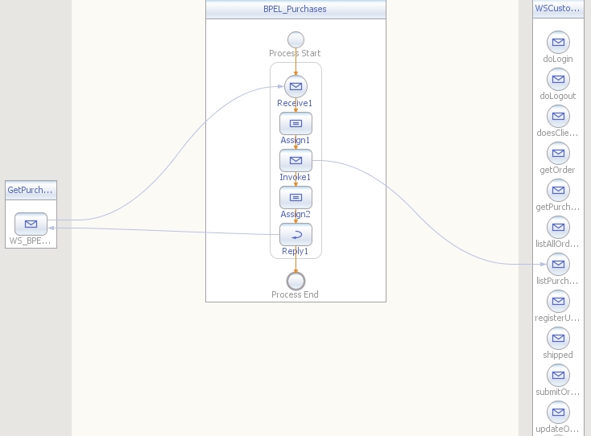

### process to perform the user cart checkout

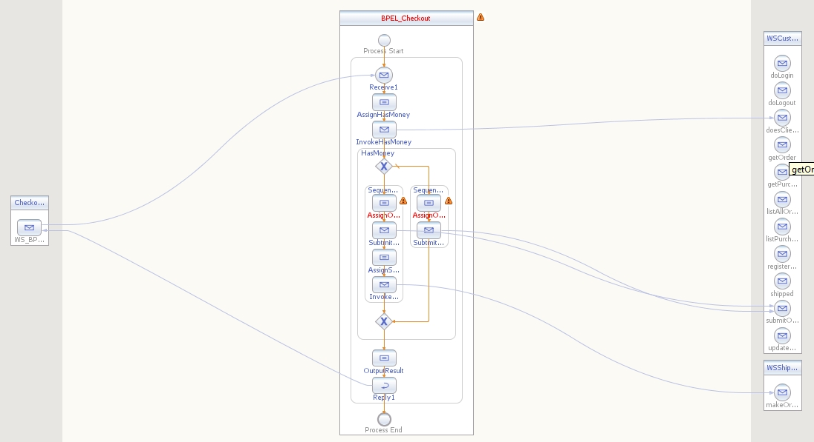

### process that processes a shipped order

